Introduction

Our study focuses on how different numbers of C60 cycles influence the internal resistance of the cells. Specifically, we examined how variations in resistance between contacts and components, series resistance, and resistance through the perovskite crystals, shunt resistance, contribute to overall performance, particularly fill factor and efficiency.

Background

The shunt resistance is analogous to leakage current. By analyzing the slope of the IV curve near zero voltage, as seen in Figure 1, we can find a relationship representing the shunt resistance with the experimental IV data. As the slope converges to zero, the cell has fewer losses and is more efficient. The same process can be conducted near the open circuit voltage to represent the cells series resistance, which is analogous to the cells resistance between components, seen in Figure 2. As the slope near Voc goes to infinity, the resistance goes to zero (Ohm’s law) and the cell becomes more efficient.

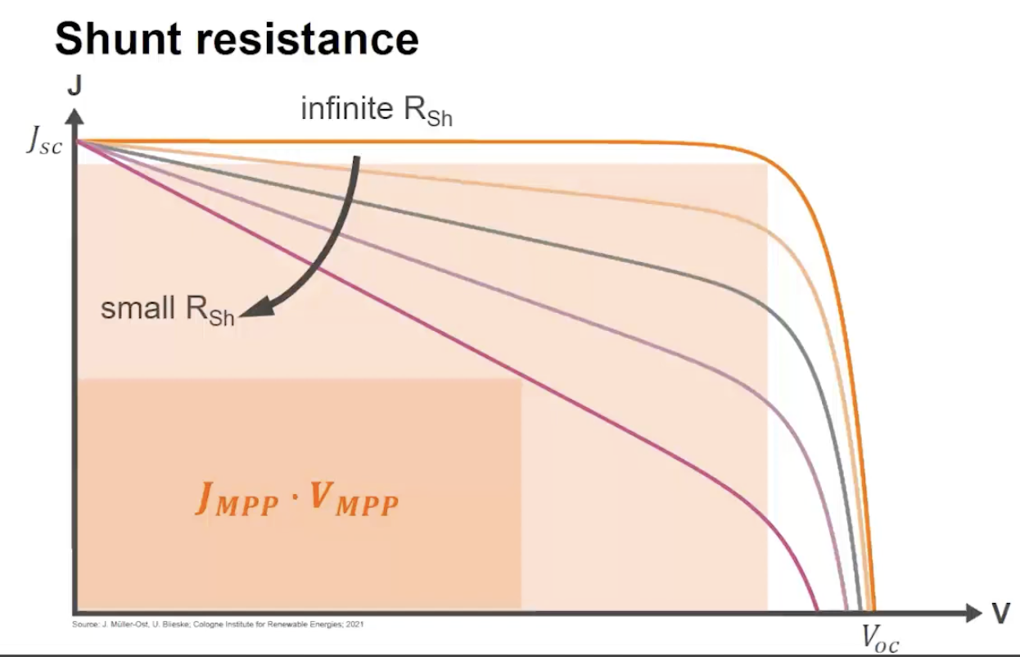Fig. 1: Shunt Resistance Variation and its Impact on Mpp

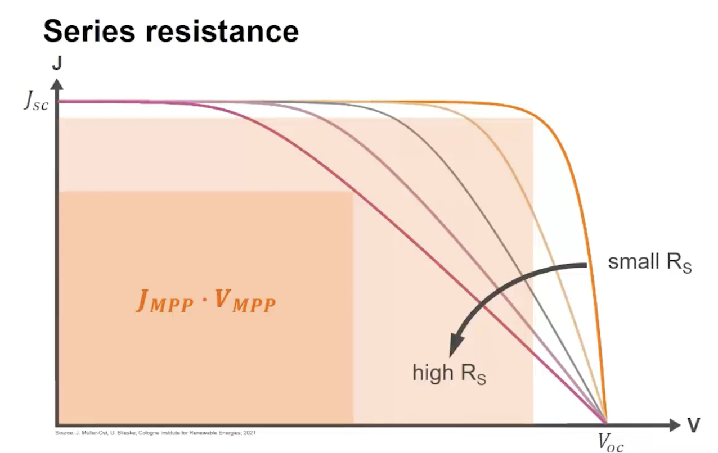
Fig. 2: Series Resistance Variation and its Impact on Mpp

Data Collection

In order to compute the shunt resistance, the first ten current values with positive voltage for each cell’s IV data were used to create a line of best fit. The slope of this line was the corresponding shunt resistance. The shunt data was averaged for every cell this semester with the same number of C60 cycles. Similarly, five data points near Voc were used to determine the series resistance. Some cells exhibited strange behavior week-to-week, so any cells with R² values greater than 0.9 were removed from the average. In conjunction with resistance values, we plotted the average fill factor over the stressing period for each number of C60 cycles, Figure 3, to show any obvious trends that we should consider when analyzing our data.
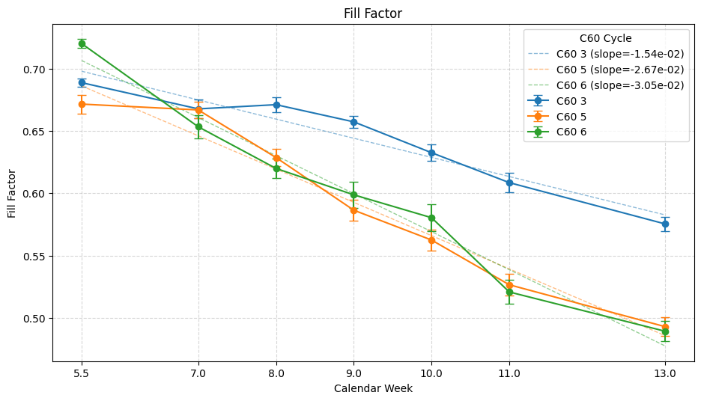

Figure 3: Fill Factor for Each C60 Cycles

Using the experimental fill factor, series resistance, and shunt resistance, we chose to create a multivariable linear regression model (Equation 1) to see how much impact the changing resistance values had on the fill factor.
$FF = β_{0}+β_{1}(R_{Sh})+β_{2}(R_{S})$ (Eq. 1)

The magnitude of the corresponding beta values represents how much the fill factor changes for every one-unit difference in the respective resistance values. Table 1 shows the beta values for each number of C60 cycles based on their respective linear regression models.

Table 1: Beta Values from Multivariable Linear Regression
C60 Cycles | β₁ (Shunt) | Β₂ (Series)
3 | 0.014 ± 0.0010 | -0.045 ± 0.0054
5 | 0.0089 ± 0.00068 | -0.16 ± 0.011
6 | 0.012 ± 0.00067 | -0.11 ± 0.013

These regression models were then cross-referenced with the fill factor data from each cell, as shown in Figure 4, to show how well the linear regression model fits.

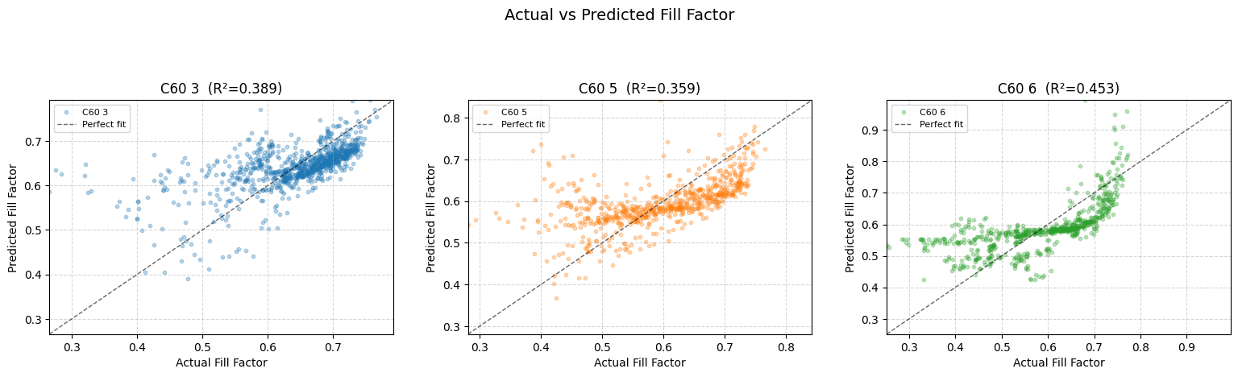
Figure 4: Actual vs. Experimental Fill Factor

The diagonal line through each graph in Figure 4 represents the predicted fill factor using the experimentally-derived beta values. The points represent every pixel of every cell throughout the testing period.

Analysis

Using the multivariable linear regression model, we find that the R² values for 5 and 6 cycles seem to have a higher impact on fill factor than that of 3 cycles. And by factoring in the respective beta values, it can be seen that the series resistance of the cells with 5 and 6 C60 cycles has roughly an order of magnitude higher impact on fill factor than that of shunt resistance. One way this data can be interpreted is that the series resistance of cells with 5 or 6 C60 cycles has a moderate impact on the cell’s efficiency.

This analysis is limited for a number of reasons. First, additional variables beyond series and shunt resistance are likely influencing the results. Second, the R² value for 3 C60 cycles is low enough to assume near-zero impact of FF by resistances and a better model will be needed to explain degradation rates. Third, many cells displayed strange behavior on a week-to-week basis. We did our best to omit outliers, but the data must be taken at face value.

Conclusion

In conclusion, while there are many factors affecting the performance of perovskite solar cells, we found that for cells which underwent 5 and 6 C60 cycles there is at least a small correlation between the increasing series resistance and the decreasing fill factor over the course of seven weeks of constant stressing. In future experiments, we might suggest using a different model to explain degradation rates, and better represent the data.

Author Contributions

Greg - Worked with most of the coding / data structures. Researched various statistical analysis to prove our findings.

Medelyne - Helped analyze and interpret results.

Jay - Spoke with Joe and confirmed the project scope. Assisted with first-principles understanding of associated physics topics. Helped analyze data and interpret results.

AI Use Statement

AI was used pretty heavily for this final project. While most of our data collection was done on our own, this final project contained much of what Claude Ai produced for code. The time allotted was limited given our goals and there were many coding projects that were in need of being completed. By using AI for the code, we were able to focus on the underlying logic going into the code, the preferred data structures, interpreting output, and putting together something meaningful for NREL in the time that we had. We made sure we understood all of the code before including anything into our project. Over all we were able to research a wide range of data and correctly display our findings through graphs, charts, and console output.

